EXP.NO: 5
Write a Servlet to demonstrate the difference
between HTTP GET and POST methods by creating
AIM:
To demonstrate the difference between the HTTP GET and POST methods by creating a
form in an HTML page and handling the form submissions using two different HTTP
methods in a Java Servlet.
ALGORITHM:
1. Input:
• The user fills out a web form with their name and email.
• The form will use both GET and POST methods for data submission.

2. Steps for Creating and Handling the HTTP GET and POST Requests:
1. Create an HTML Form:
o Design an HTML form with two input fields: one for the name and one for the
email.
o Create two buttons to allow the user to submit the form using GET or POST
methods.
o Use the action attribute to define the Servlet URL and specify the form
method (either GET or POST).

2. Create the Servlet to Handle GET and POST Requests:
o Write a Java Servlet class that will handle both GET and POST requests.
o The servlet will have two methods:
▪ doGet() to handle the GET requests.
▪ doPost() to handle the POST requests.
o In both methods, retrieve the form data using request.getParameter().
o In the doGet() method, process and display the data in the URL.
o In the doPost() method, process and display the data in the HTTP request
body.

3. Handle GET Requests in the Servlet:
o In the doGet() method, use request.getParameter() to retrieve the name and
email submitted via GET.
o Output the data as a response, including the name and email in the URL
(visible to the user).

4. Handle POST Requests in the Servlet:
o In the doPost() method, use request.getParameter() to retrieve the name and
email submitted via POST.
o Output the data as a response, displaying the name and email without
exposing them in the URL (more secure).

5. Return the Output:
o The Servlet should return an HTML page displaying the name and email
entered by the user.
o For the GET method, the output should be visible in the URL.
o For the POST method, the output should be visible in the response body, not
the URL.

6. Deploy and Test the Servlet:
o Compile the Servlet class and deploy it to a Servlet container (like Apache
Tomcat).
o Test the form using GET and POST methods to see the difference in data
submission.

7. Observe and Compare GET and POST Results:
o Test the GET method: The form data is sent in the URL.
o Test the POST method: The form data is sent in the HTTP request body, not
visible in the URL.
CODE:
Index.html:
<!DOCTYPE html>
<html>
<head>
<title>MiniTimes India</title>

<style>

body{
font-family: Arial;
margin:0;
background:#f2f2f2;
}

header{
background:#c40000;
color:white;
padding:20px;
text-align:center;
font-size:30px;
font-weight:bold;
}

nav{
background:#222;
padding:10px;
text-align:center;
}

nav a{
color:white;
margin:15px;
text-decoration:none;
font-weight:bold;
}

.container{
width:40%;
margin:auto;
margin-top:40px;
background:white;
padding:30px;
box-shadow:0px 0px 10px gray;
}

h2{
text-align:center;
}

input{
width:100%;
padding:10px;
margin:8px 0;
}

button{
padding:10px;
border:none;
color:white;
cursor:pointer;
width:100%;
}

.getbtn{
background:#007bff;
}

.postbtn{
background:#28a745;
}

footer{
margin-top:40px;
background:#222;
color:white;
text-align:center;
padding:10px;
}

</style>

</head>

<body>

<header>
MiniTimes India
</header>

<nav>
<a href="#">Home</a>
<a href="#">Politics</a>
<a href="#">Sports</a>
<a href="#">Technology</a>
<a href="#">Contact</a>
</nav>

<div class="container">

<h2>Subscribe for Breaking News</h2>

<form action="FormServlet" method="get">

<label>Name</label>
<input type="text" name="name">

<label>Email</label>
<input type="text" name="email">

<button class="getbtn">Subscribe using GET</button>

</form>

<br>

<form action="FormServlet" method="post">

<label>Name</label>
<input type="text" name="name">

<label>Email</label>
<input type="text" name="email">

<button class="postbtn">Subscribe using POST</button>

</form>
</div>
<footer>
© 2025 MiniTimes India | Daily Digital News Portal
</footer>
</body>
</html>
Sevlet.java:
package com.example;

import java.io.IOException;
import java.io.PrintWriter;

import jakarta.servlet.ServletException;
import jakarta.servlet.annotation.WebServlet;
import jakarta.servlet.http.*;

@WebServlet("/FormServlet")

public class FormServlet extends HttpServlet {

protected void doGet(HttpServletRequest request, HttpServletResponse response)
throws ServletException, IOException {

response.setContentType("text/html");
PrintWriter out=response.getWriter();

String name=request.getParameter("name");
String email=request.getParameter("email");

out.println("<html>");
out.println("<head>");
out.println("<title>MiniTimes India</title>");

out.println("<style>");
out.println("body{font-family:Arial;margin:0;background:#f2f2f2;}");
out.println("header{background:#c40000;color:white;padding:20px;text-align:center;font-size:30px;}");
out.println("nav{background:#222;padding:10px;text-align:center;}");
out.println("nav a{color:white;margin:15px;text-decoration:none;font-weight:bold;}");
out.println(".container{width:40%;margin:auto;margin-top:40px;background:white;padding:30px;box-shadow:0px 0px 10px gray;}");
out.println("footer{margin-top:40px;background:#222;color:white;text-align:center;padding:10px;}");
out.println("</style>");

out.println("</head>");
out.println("<body>");

out.println("<header>MiniTimes India</header>");

out.println("<nav>");
out.println("<a href='#'>Home</a>");
out.println("<a href='#'>Politics</a>");
out.println("<a href='#'>Sports</a>");
out.println("<a href='#'>Technology</a>");
out.println("</nav>");

out.println("<div class='container'>");

out.println("<h2>GET Method Subscription</h2>");
out.println("<p><b>Name:</b> "+name+"</p>");
out.println("<p><b>Email:</b> "+email+"</p>");
out.println("<p style='color:blue;'>Data is visible in the URL because GET method is used.</p>");

out.println("</div>");

out.println("<footer>© 2025 MiniTimes India</footer>");

out.println("</body>");
out.println("</html>");
}

protected void doPost(HttpServletRequest request, HttpServletResponse response)
throws ServletException, IOException {

response.setContentType("text/html");
PrintWriter out=response.getWriter();

String name=request.getParameter("name");
String email=request.getParameter("email");

out.println("<html>");
out.println("<head>");
out.println("<title>MiniTimes India</title>");

out.println("<style>");
out.println("body{font-family:Arial;margin:0;background:#f2f2f2;}");
out.println("header{background:#c40000;color:white;padding:20px;text-align:center;font-size:30px;}");
out.println("nav{background:#222;padding:10px;text-align:center;}");
out.println("nav a{color:white;margin:15px;text-decoration:none;font-weight:bold;}");
out.println(".container{width:40%;margin:auto;margin-top:40px;background:white;padding:30px;box-shadow:0px 0px 10px gray;}");
out.println("footer{margin-top:40px;background:#222;color:white;text-align:center;padding:10px;}");
out.println("</style>");

out.println("</head>");
out.println("<body>");

out.println("<header>MiniTimes India</header>");

out.println("<nav>");
out.println("<a href='#'>Home</a>");
out.println("<a href='#'>Politics</a>");
out.println("<a href='#'>Sports</a>");
out.println("<a href='#'>Technology</a>");
out.println("</nav>");

out.println("<div class='container'>");

out.println("<h2>POST Method Subscription</h2>");
out.println("<p><b>Name:</b> "+name+"</p>");
out.println("<p><b>Email:</b> "+email+"</p>");
out.println("<p style='color:green;'>Data is NOT visible in the URL because POST method is used.</p>");

out.println("</div>");

out.println("<footer>© 2025 MiniTimes India</footer>");

out.println("</body>");
out.println("</html>");
}

}

OUTPUT:

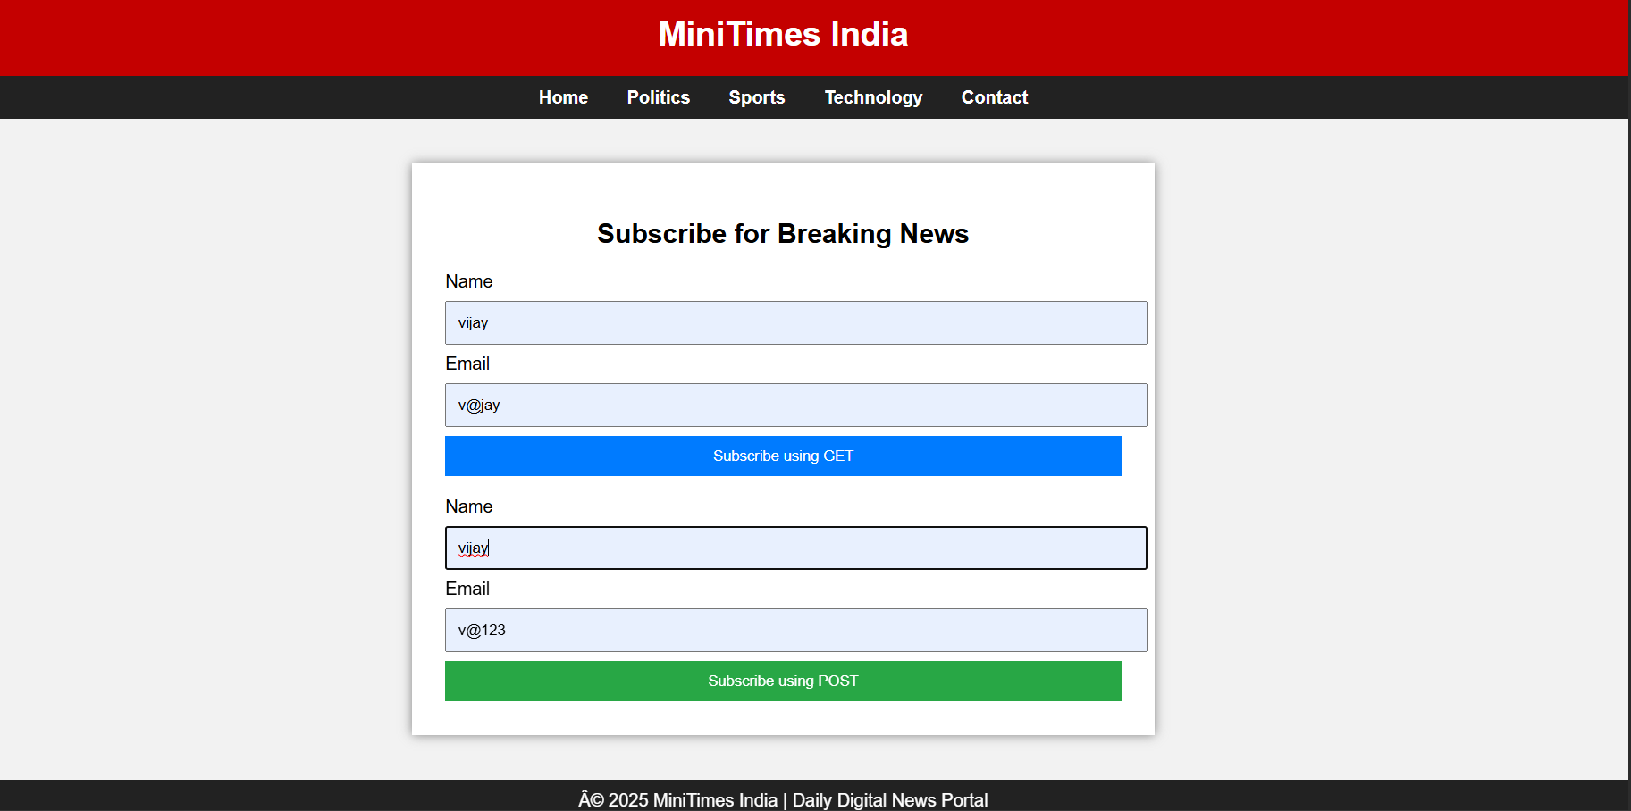

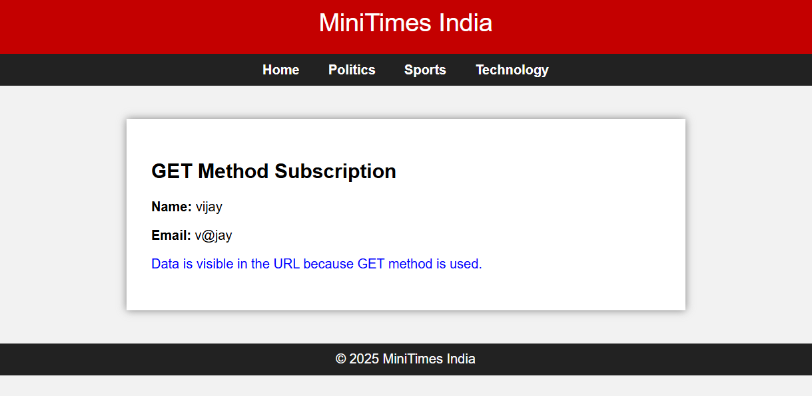
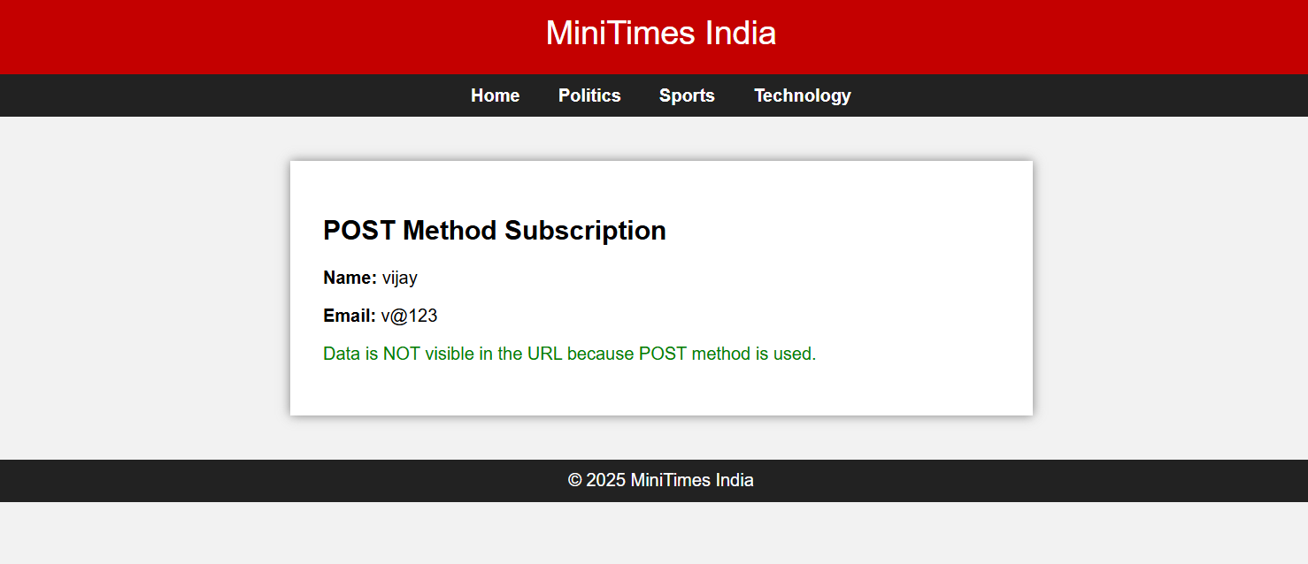

Result:
Html Page is created with embedded Bangalore map along with hot spot, frames ,map & Links.

